|  |
| --- |
| **ARENITO MINERALS & CHEMICALS CORPORATION** |
| **WATER ABSORPTION/ADSORPTION**  **MOISTURE RETENTION AND RELEASE**  **of**  **KMI 12X20 MESH ZEOLITE** |

June 1, 2015

**Prepared by:**

LuVerne E. W. Hogg

Canadian Institute of Mining, Metallurgy and Petroleum

#148963

***Introduction***

Arenito Minerals and Chemicals Corporation (“Arenito”) was requested by KMI Zeolite Inc. (“KMI”) to conduct a test on KMI’s 12x20 mesh zeolite’s ability to absorb, adsorb, retain and subsequently release moisture over time, as well as the contributing atmospheric conditions. The test was to replicate the zeolite’s performance as an infill for synthetic grass.

***Test Procedures***

To determine the amount of water the zeolite would absorb and adsorb, two pounds (32 ounces) of KMI 12x20 mesh zeolite was mixed with 32 ounces of water. The zeolite absorbed and adsorbed the water immediately.

*Absorption: The process whereby zeolite takes up water through porosity and permeability. Adsorption: the attaching of molecules of water in the zeolite molecular structure. Absorption and adsorption are referred to as sorption. Zeolites can cycle from hydration to dehydration with no change in shape.*

Beyond saturation, six ounces was removed by draining the zeolite on an 80 mesh screen, resulting in 32 ounces of zeolite containing 26 ounces of water, with a total weight of 58 ounces or 3.625 pounds. The KMI zeolite, completely hydrated, will hold 81% of its dry weight with water.

The 3.625 pounds of saturated zeolite was placed on an impermeable plastic sheet and formed into a rectangle measuring 37 x 4.5 inches, by ½ inch deep (see Plate 1). The rectangle was placed on an outside lab bench in the shade so the zeolite was only exposed to indirect ultraviolet light. Evaporation is the mechanism by which the water in the zeolite is changed to water vapor. The HygroSet Digital Hygrometer was used to measure temperature and relative humidity over time in order to measure the zeolite’s dehydration performance.

1

***Summary of the Results***

Thirteen measurements of the atmospheric conditions of temperature, humidity, wind and light were recorded over a 25 hour period. The temperature ranged from 60° F to 81° F. The relative humidities ranged from 33% to 44%. No rain fell during the period and winds varied from two mph to 15 mph. There was 15 hours of indirect ultra violet light exposure during the 25 hour test period. At the conclusion of the trial period the zeolite back to its dehydrated state weighing two pounds.

***Conclusions***

1. KMI zeolite absorbs and adsorbs 81% of its dry weight with water.
2. The KMI zeolite releases 81% of the absorbed and adsorbed water as a result of the atmospheric conditions of temperature, humidity, wind and ultra violet light.
3. The inherent variable atmospheric conditions of heat, moisture, wind and light determine the time factor of the zeolite’s release of total contained moisture.
4. The dehydration and subsequent evaporation of the water contained in the zeolite produces a cooling effect.
5. The KMI zeolite will continue to cycle between hydration and dehydration indefinitely.
6. Dehydration rate goes up as the temperature rises.
7. As the relative humidity goes up the dehydration of the zeolite rate falls.
8. As wind or air movement increases the rate of dehydration increases.
9. Plant transpiration is the evaporation of water from plant leaves. The use of KMI zeolite in the synthetic turf has an interesting effect as it creates a replica of transpiration from natural grass, thereby creating a more natural environment.

2

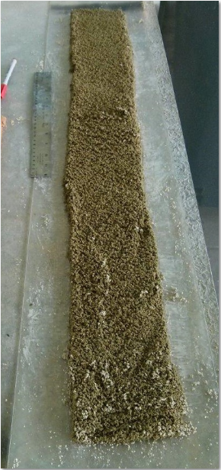

Plate 1

As water evaporates, the KMI zeolite grains resume their dehydrated color.

3